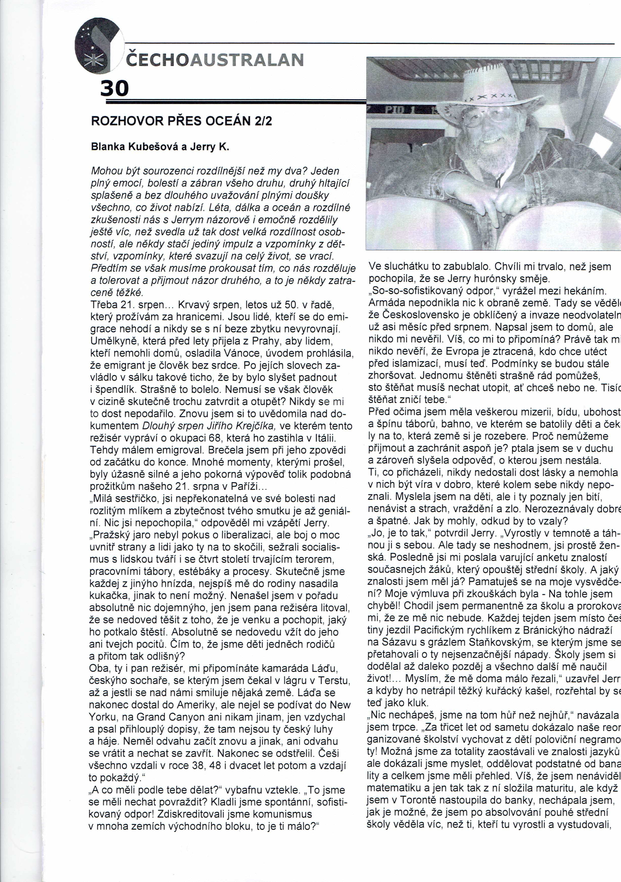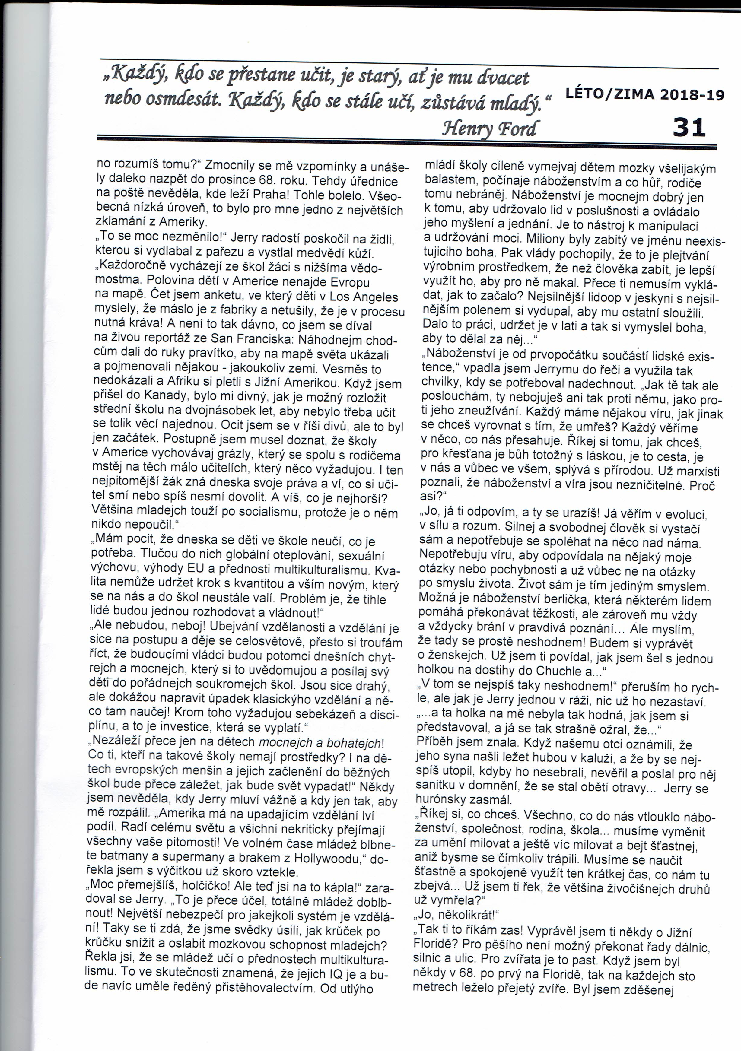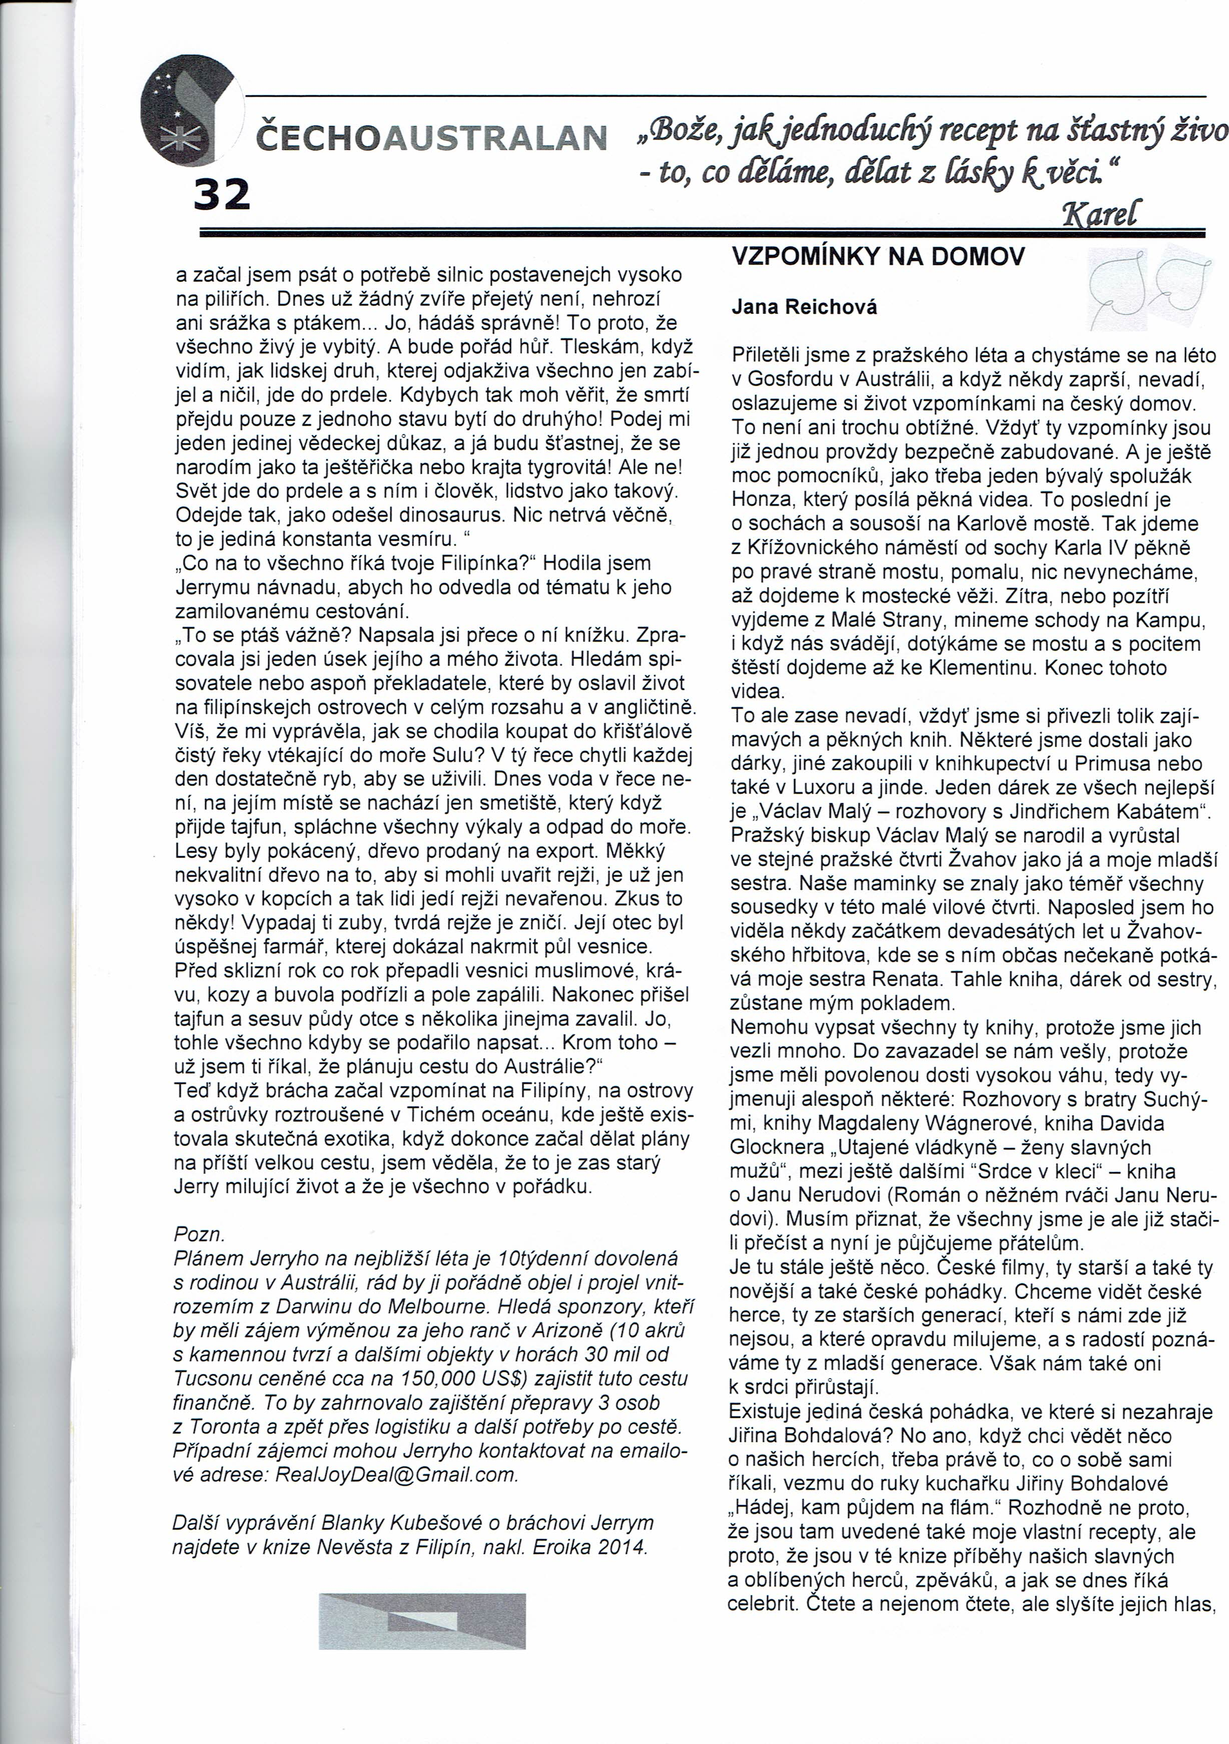

[file:///C:/Users/User/Documents/cechoaustralan-leto-zima-2018.pdf](../../../../../C:/Users/User/Documents/cechoaustralan-leto-zima-2018.pdf)